Project Development Phase Model Performance Test

Date | 10 January 2026
Team ID | LTVIP2026TMIDS38170
Project Name | Hematovision: advanced blood cell classification using transfer learning
Maximum Marks

Model Performance Testing:
Project team shall fill the following information in model performance testing template.

S.No. | Parameter | Values | 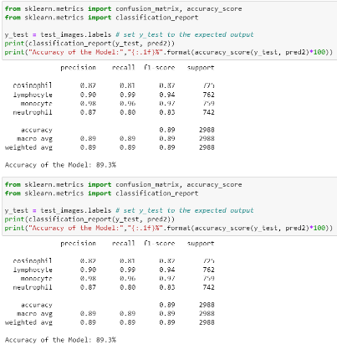  Screenshot
1. | Model Summary | Model: MobileNetV2 (Transfer Learning) with an added Dense layer. Total parameters: 2,586,948. Trainable parameters: 328,964.  Non-trainable parameters: 2,257,984. | 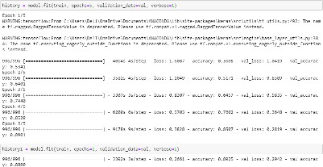
2. | Accuracy | Training Accuracy – 0.89.3 (from Epoch 12/15)  Validation Accuracy - 0.81462 (from Epoch 12/15)
3. | Fine Tunning Result( if Done) | Validation Accuracy -  Fine-tuning of the pre-trained MobileNetV2 base model was not performed. Only the newly added dense layer was trained.

